“Today we celebrate the Lord's Supper."

During our service, we celebrate the Lord's Supper. If you are a visitor and are not a member of a congregation of The Lutheran Church - Missouri Synod, we encourage you to speak with Pastor Vossler or one of our elders before the service about what we believe concerning the Sacrament.

December 3rd, 2023
First Sunday in Advent

Pastor Christopher P. Vossler
Organist: Heidi Stecker

ST PAUL LUTHERAN CHURCH-LCMS
2045 LYNN RD | SANFORD, MI 48657

-Welcomes you!-

Divine Service Setting III LSB 184

Hymn: 336 Lo! He Comes with Clouds Descending
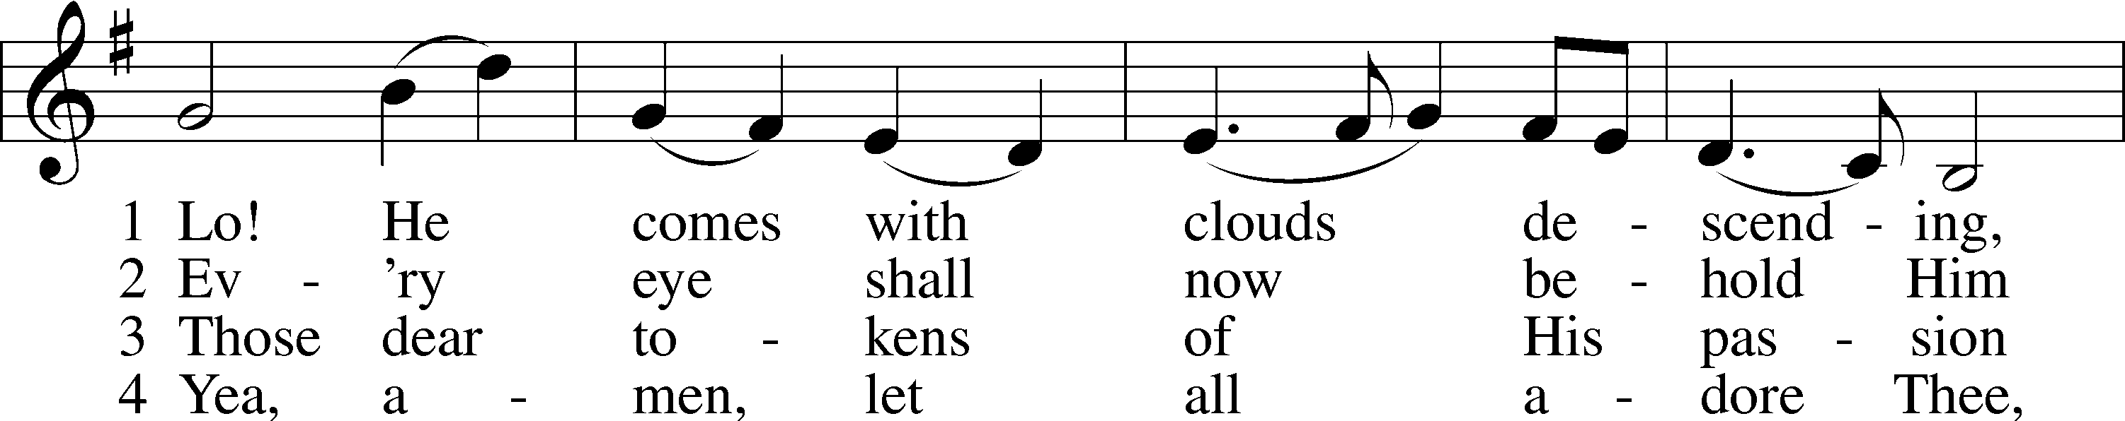
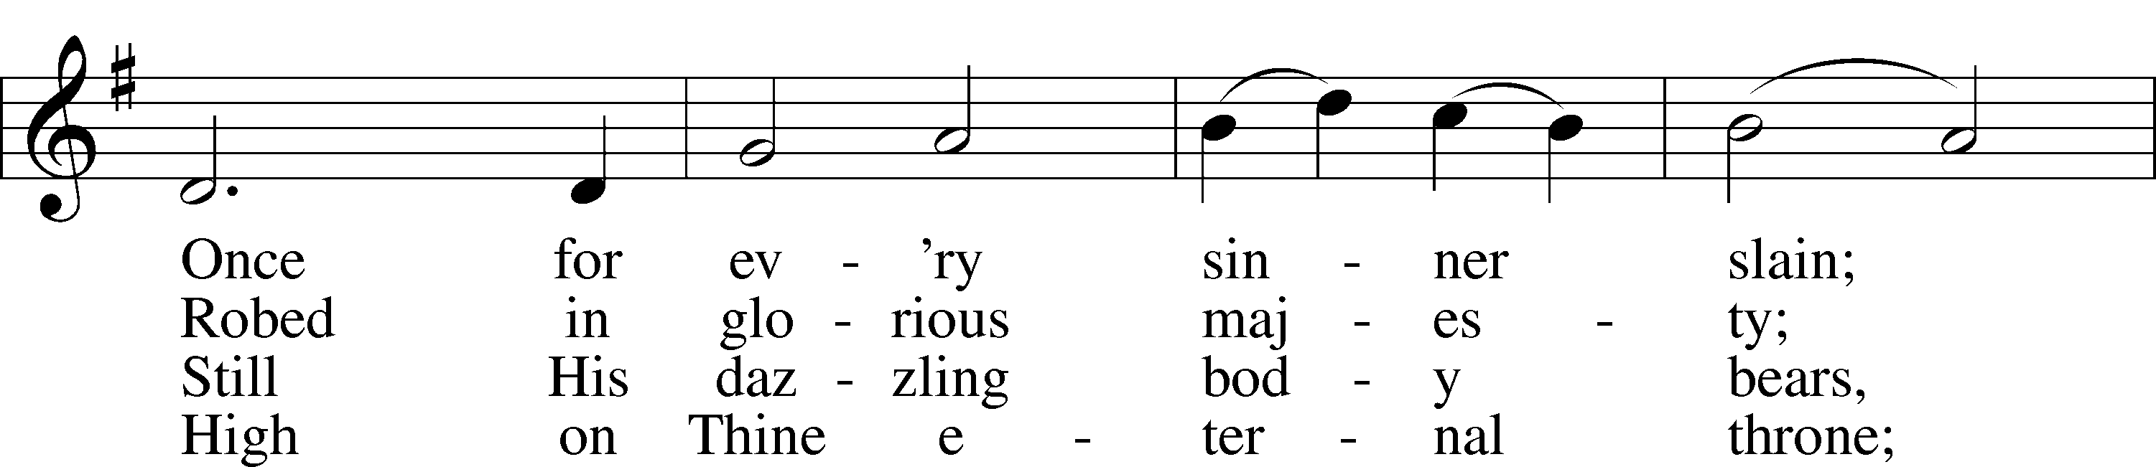
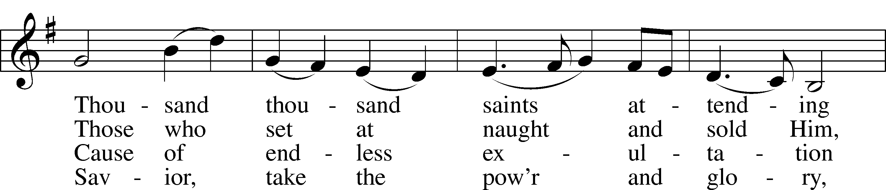
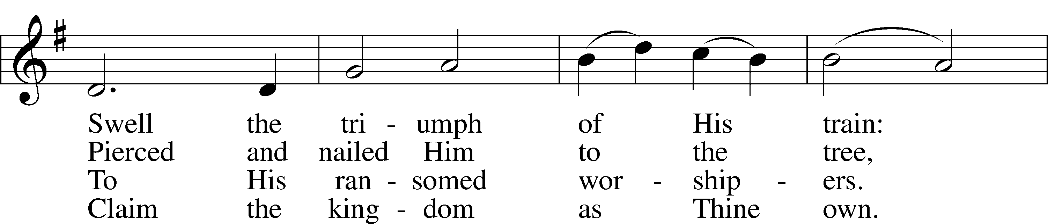
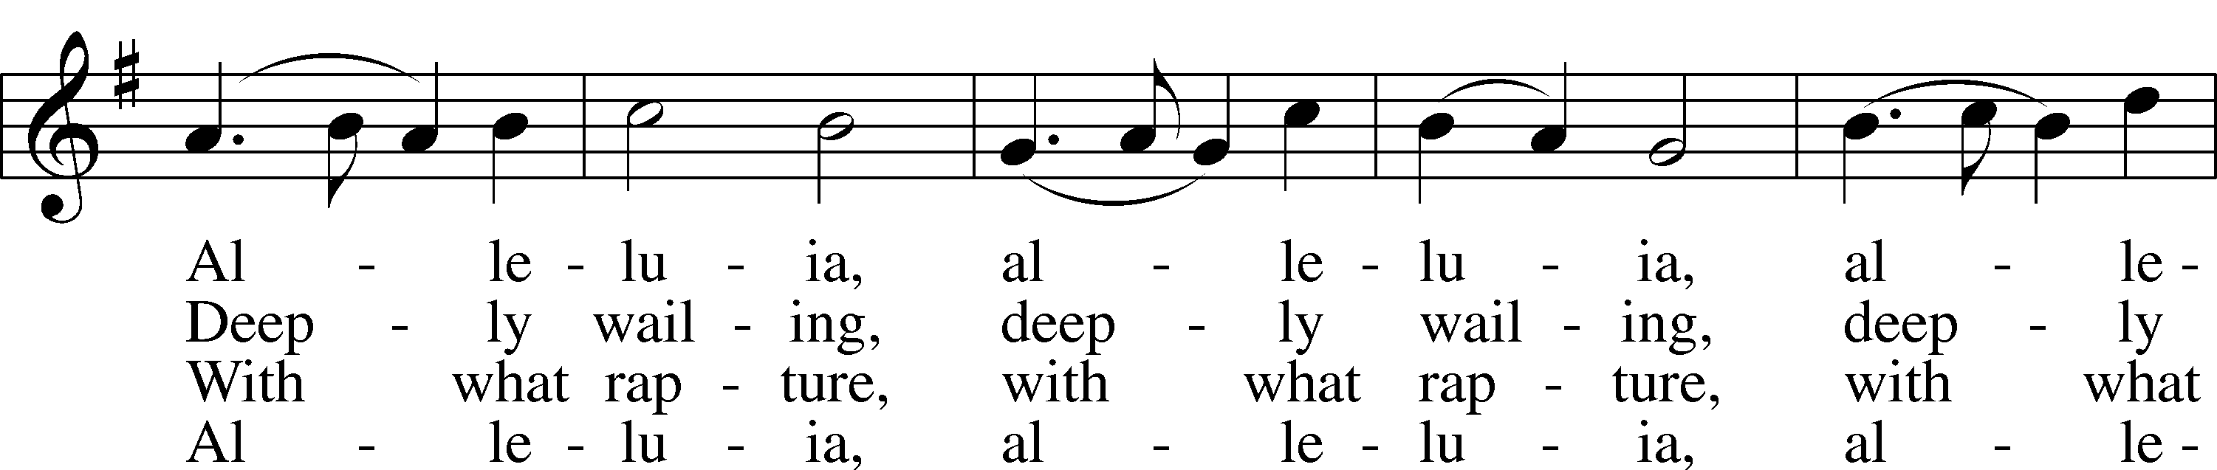
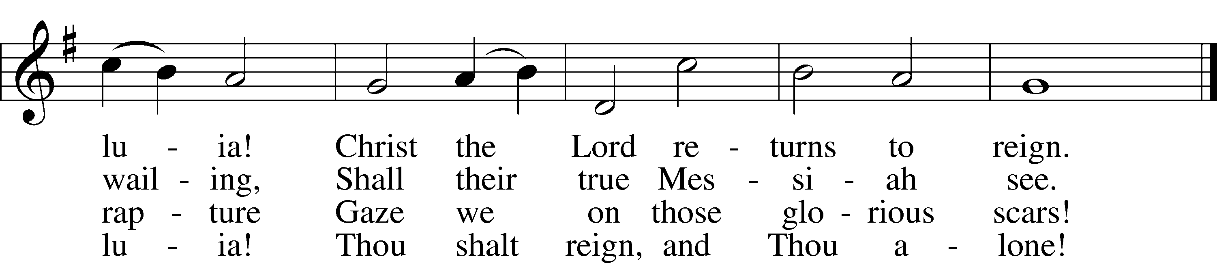

Stand
Confession and Absolution

The sign of the cross may be made by all in remembrance of their Baptism.

P In the name of the Father and of the T Son and of the Holy Spirit.
C Amen.

P Beloved in the Lord! Let us draw near with a true heart and confess our sins unto God our Father, beseeching Him in the name of our Lord Jesus Christ to grant us forgiveness.

P Our help is in the name of the Lord,
C who made heaven and earth.
P I said, I will confess my transgressions unto the Lord,
C and You forgave the iniquity of my sin.

Silence for reflection on God’s Word and for self-examination.

P O almighty God, merciful Father,
C I, a poor, miserable sinner, confess unto You all my sins and iniquities with which I have ever offended You and justly deserved Your temporal and eternal punishment. But I am heartily sorry for them and sincerely repent of them, and I pray You of Your boundless mercy and for the sake of the holy, innocent, bitter sufferings and death of Your beloved Son, Jesus Christ, to be gracious and merciful to me, a poor, sinful being.

P Upon this your confession, I, by virtue of my office, as a called and ordained servant of the Word, announce the grace of God unto all of you, and in the stead and by the command of my Lord Jesus Christ I forgive you all your sins in the name of the Father and of the T Son and of the Holy Spirit.
C Amen.

Service of the Word

Introit Psalm 25:1–3; antiphon: Zechariah 9:9b, alt.
Behold, your king is com- | ing to you;*
righteous and having sal- | vation.
To you, | O Lord,*
I lift | up my soul.
O my God, in you I trust; let me not be | put to shame;*
let not my enemies exult | over me.
Indeed, none who wait for you shall be | put to shame;*
they shall be ashamed who are wantonly | treacherous.
Behold, your king is com- | ing to you;*
righteous and having sal- | vation.

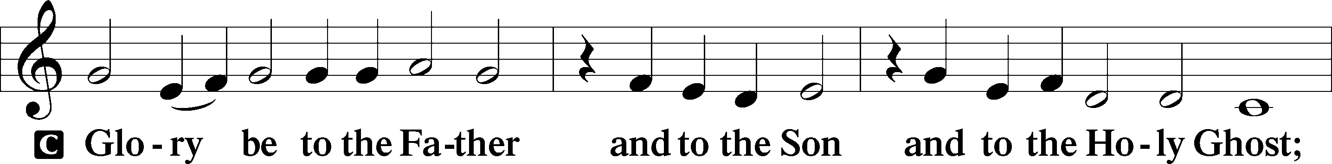
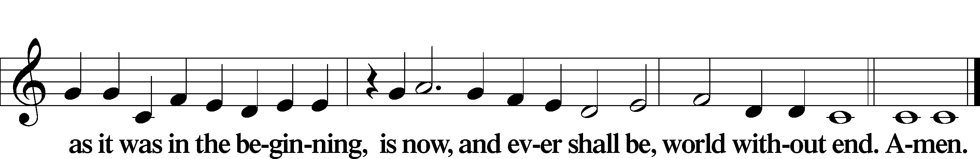

Kyrie LSB 186
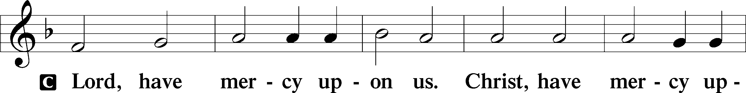
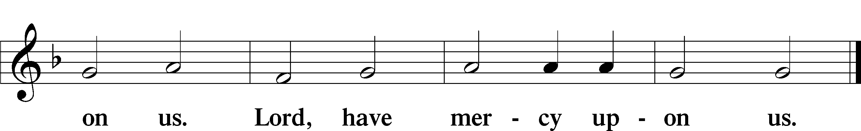

Salutation and Collect of the Day
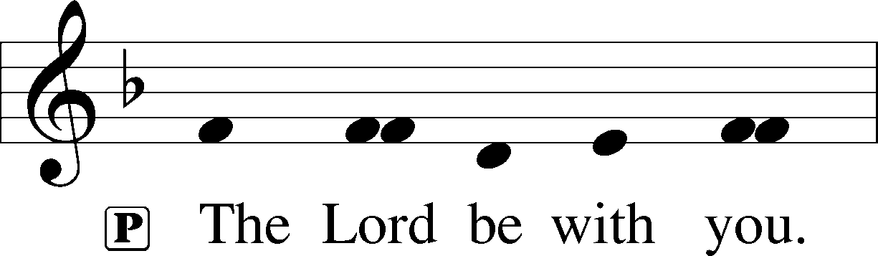
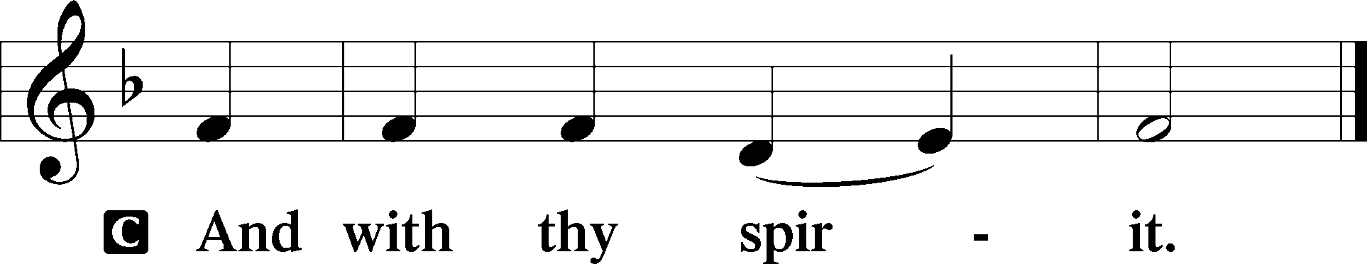

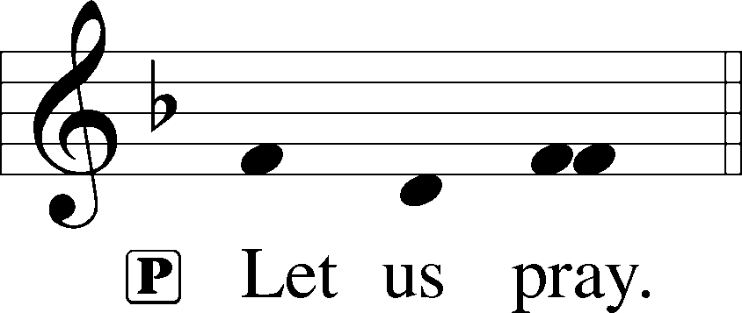

C Stir up Your power, O Lord, and come, that by Your protection we may be rescued from the threatening perils of our sins and saved by Your mighty deliverance; for You live and reign with the Father and the Holy Spirit, one God, now and forever.

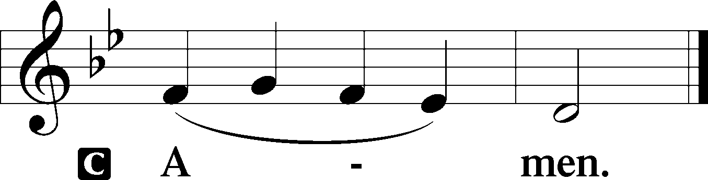

Sit

Old Testament Reading Isaiah 64:1–9
1Oh that you would rend the heavens and come down,
that the mountains might quake at your presence—
2 as when fire kindles brushwood
and the fire causes water to boil—
to make your name known to your adversaries,
and that the nations might tremble at your presence!
3When you did awesome things that we did not look for,
you came down, the mountains quaked at your presence.
4From of old no one has heard
or perceived by the ear,
no eye has seen a God besides you,
who acts for those who wait for him.
5You meet him who joyfully works righteousness,
those who remember you in your ways.
Behold, you were angry, and we sinned;
in our sins we have been a long time, and shall we be saved?
6We have all become like one who is unclean,
and all our righteous deeds are like a polluted garment.
We all fade like a leaf,
and our iniquities, like the wind, take us away.
7There is no one who calls upon your name,
who rouses himself to take hold of you;
for you have hidden your face from us,
and have made us melt in the hand of our iniquities.
8But now, O Lord, you are our Father;
we are the clay, and you are our potter;
we are all the work of your hand.
9Be not so terribly angry, O Lord,
and remember not iniquity forever.
Behold, please look, we are all your people.

A This is the Word of the Lord.
C Thanks be to God.

Gradual Zechariah 9:9; Psalm 118:26, alt.
Rejoice greatly, O daughter of | Zion.*
Shout aloud, O daughter of Je- | rusalem.
Behold, your king is com- | ing to you;*
righteous and having sal- | vation.
Blessèd is he who comes in the name | of the Lord.*
From the house of the Lord we | bless you.

Epistle 1 Corinthians 1:3–9
3Grace to you and peace from God our Father and the Lord Jesus Christ.
4I give thanks to my God always for you because of the grace of God that was given you in Christ Jesus, 5that in every way you were enriched in him in all speech and all knowledge—6even as the testimony about Christ was confirmed among you—7so that you are not lacking in any spiritual gift, as you wait for the revealing of our Lord Jesus Christ, 8who will sustain you to the end, guiltless in the day of our Lord Jesus Christ. 9God is faithful, by whom you were called into the fellowship of his Son, Jesus Christ our Lord.

A This is the Word of the Lord.
C Thanks be to God.

Please stand to honor the Holy Gospel

Alleluia LSB 190
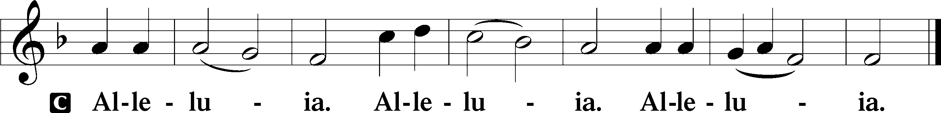

Holy Gospel Mark 13:24–37
P The Holy Gospel according to St. Mark, the thirteenth chapter.

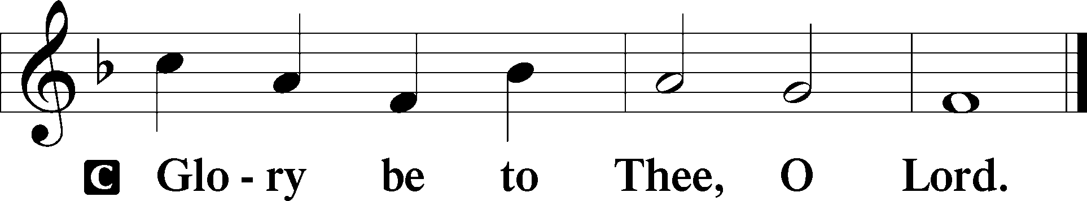

24[Jesus said:] “In those days, after that tribulation, the sun will be darkened, and the moon will not give its light, 25and the stars will be falling from heaven, and the powers in the heavens will be shaken. 26And then they will see the Son of Man coming in clouds with great power and glory. 27And then he will send out the angels and gather his elect from the four winds, from the ends of the earth to the ends of heaven.
28“From the fig tree learn its lesson: as soon as its branch becomes tender and puts out its leaves, you know that summer is near. 29So also, when you see these things taking place, you know that he is near, at the very gates. 30Truly, I say to you, this generation will not pass away until all these things take place. 31Heaven and earth will pass away, but my words will not pass away.
32“But concerning that day or that hour, no one knows, not even the angels in heaven, nor the Son, but only the Father. 33Be on guard, keep awake. For you do not know when the time will come. 34It is like a man going on a journey, when he leaves home and puts his servants in charge, each with his work, and commands the doorkeeper to stay awake. 35Therefore stay awake—for you do not know when the master of the house will come, in the evening, or at midnight, or when the cock crows, or in the morning— 36lest he come suddenly and find you asleep. 37And what I say to you I say to all: Stay awake.”

P This is the Gospel of the Lord.

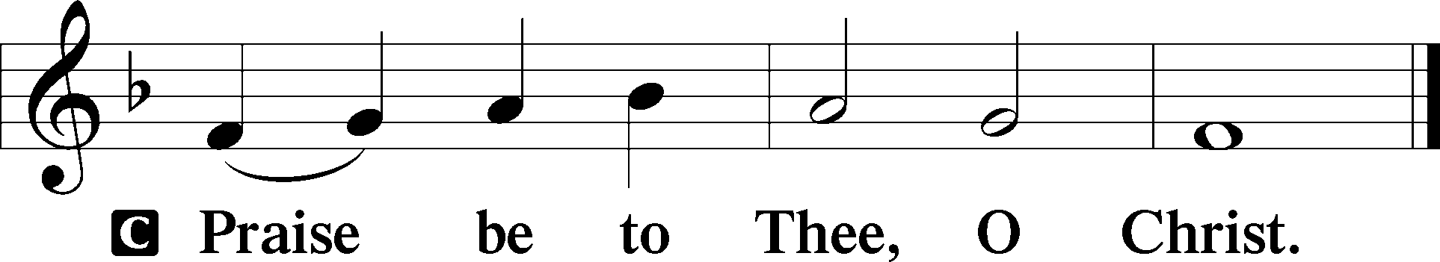

Nicene Creed
C I believe in one God, the Father Almighty, maker of heaven and earth and of all things visible and invisible.

And in one Lord Jesus Christ, the only-begotten Son of God, begotten of His Father before all worlds, God of God, Light of Light, very God of very God, begotten, not made, being of one substance with the Father, by whom all things were made; who for us men and for our salvation came down from heaven and was incarnate by the Holy Spirit of the virgin Mary and was made man; and was crucified also for us under Pontius Pilate. He suffered and was buried. And the third day He rose again according to the Scriptures and ascended into heaven and sits at the right hand of the Father. And He will come again with glory to judge both the living and the dead, whose kingdom will have no end.

And I believe in the Holy Spirit, the Lord and giver of life, who proceeds from the Father and the Son, who with the Father and the Son together is worshiped and glorified, who spoke by the prophets. And I believe in one holy Christian and apostolic Church, I acknowledge one Baptism for the remission of sins, and I look for the resurrection of the dead and the life T of the world to come. Amen.

Sit

Children’s Message
Hymn: 332 Savior of the Nations, Come
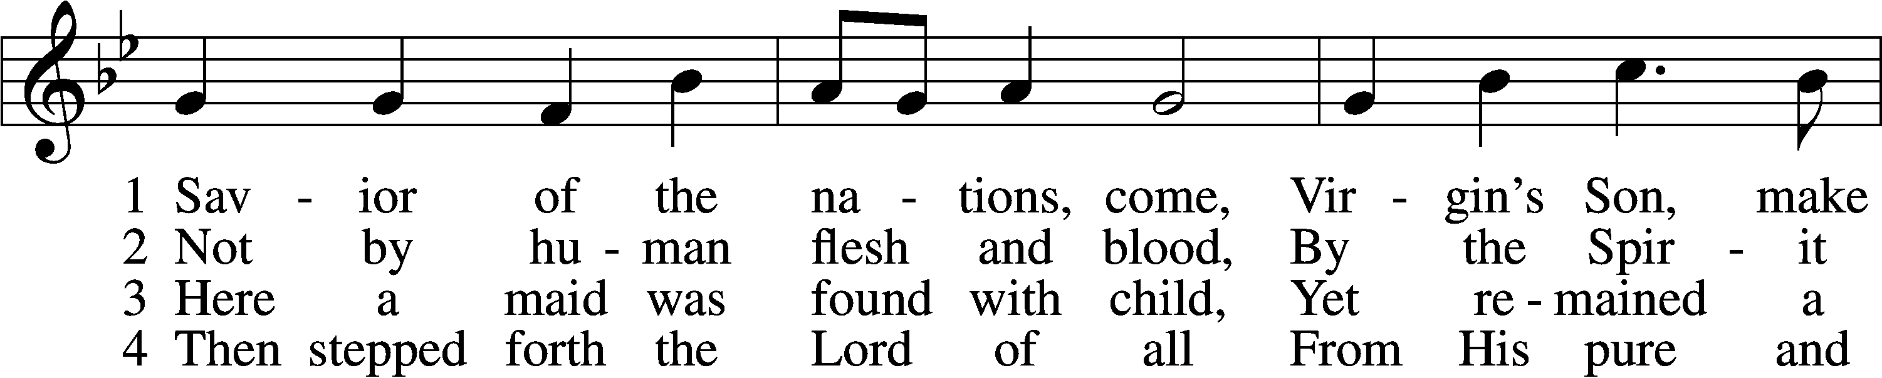
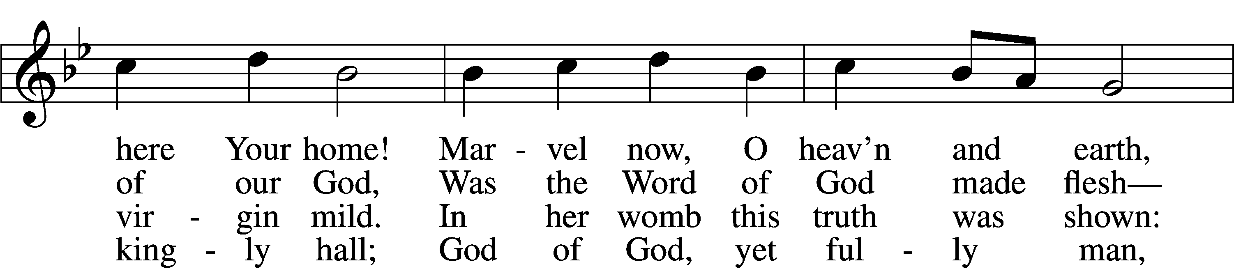
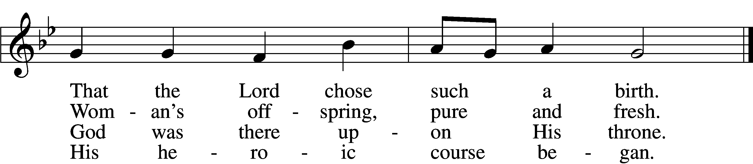

5 God the Father was His source, Back to God He ran His course. Into hell His road went down, Back then to His throne and crown.

6 For You are the Father’s Son Who in flesh the vict’ry won.
By Your mighty pow’r make whole All our ills of flesh and soul.

7 From the manger newborn light Shines in glory through the night. Darkness there no more resides; In this light faith now abides.

D 8 Glory to the Father sing, Glory to the Son, our king,
Glory to the Spirit be Now and through eternity.

Sermon “Stir Up Your Power” Collect of the Day

Pastor Christopher P. Vossler

Goal: That the hearers would look for God’s rescue and deliverance.

I. Introduction

- Why do we pray? What do we pray for?

II. Our Reasons to Pray

- What danger or fear do we face in this life?
- Why do we pray for God’s intervention?
III. The Prayer

- What does it mean for God’s power to be stirred up?
- Why do we need God to rescue and save us?
IV. The Result

- From where does our deliverance come?
V. Conclusion

P The peace of God, which passes all understanding, keep your hearts and minds in Christ Jesus.
C Amen.

Stand

Offertory LSB 192
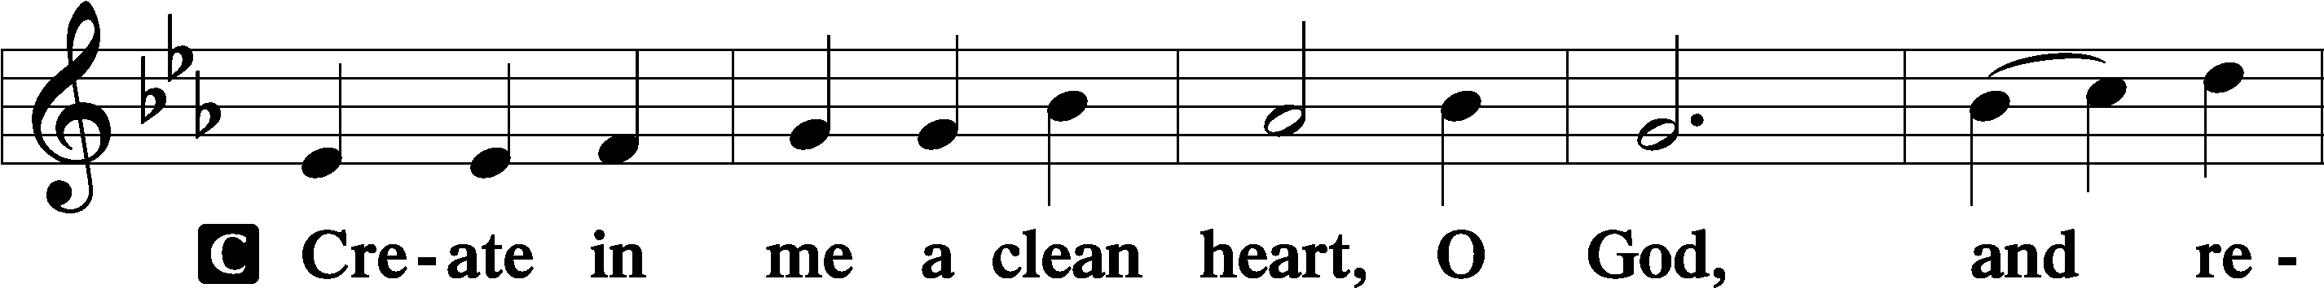
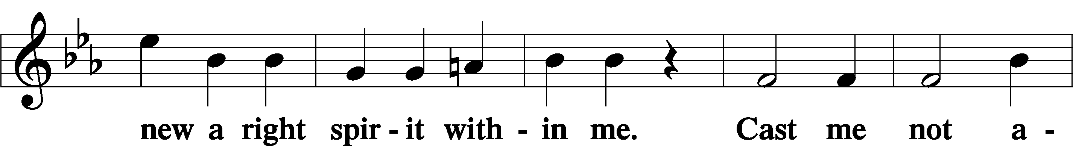
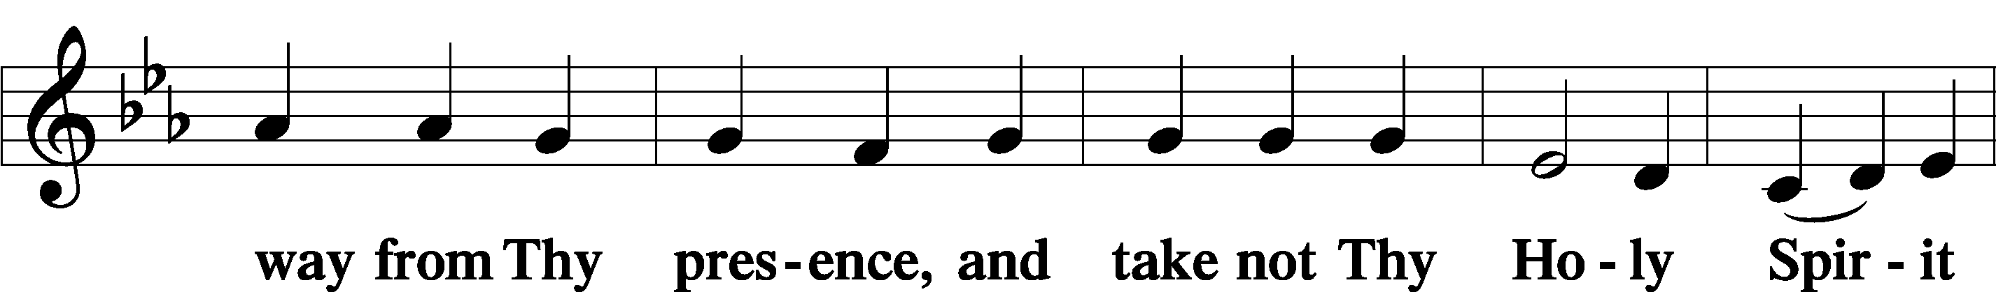
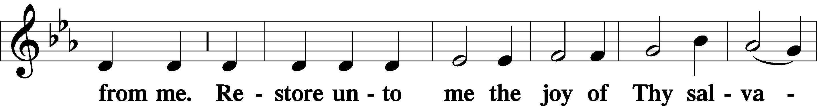
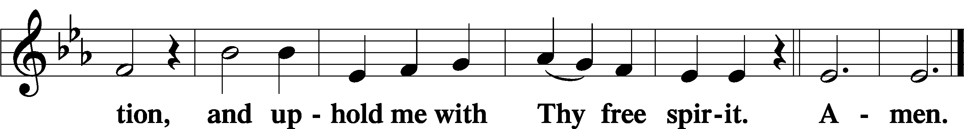

Sit

Offering

Stand

Prayer of the Church

Service of the Sacrament

Preface LSB 194

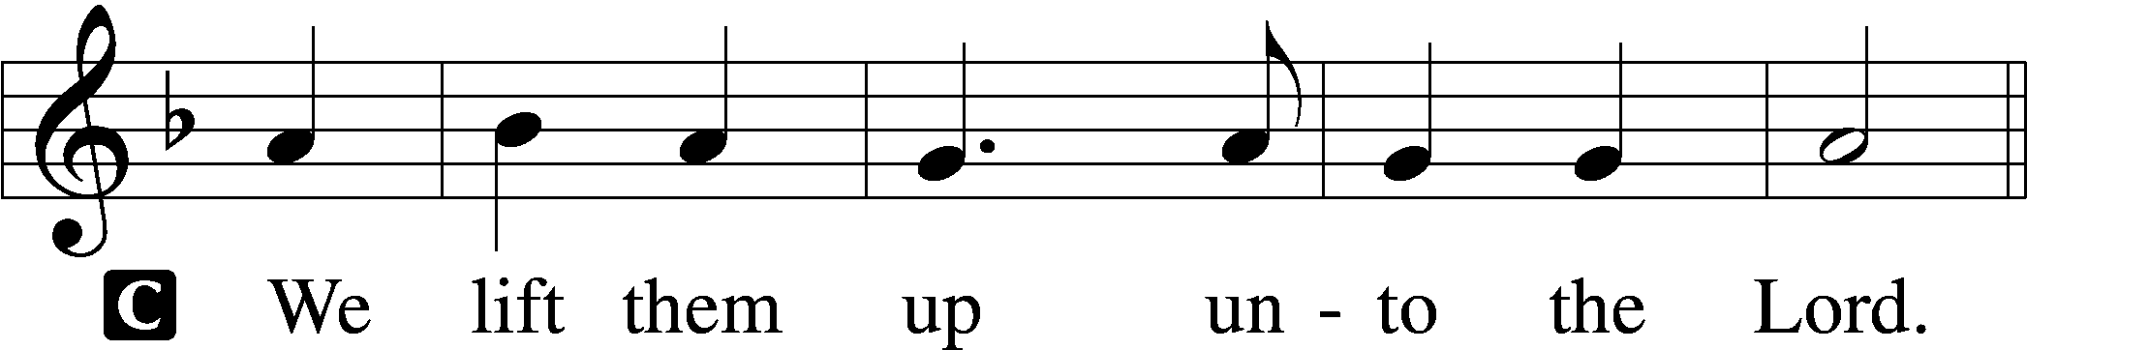

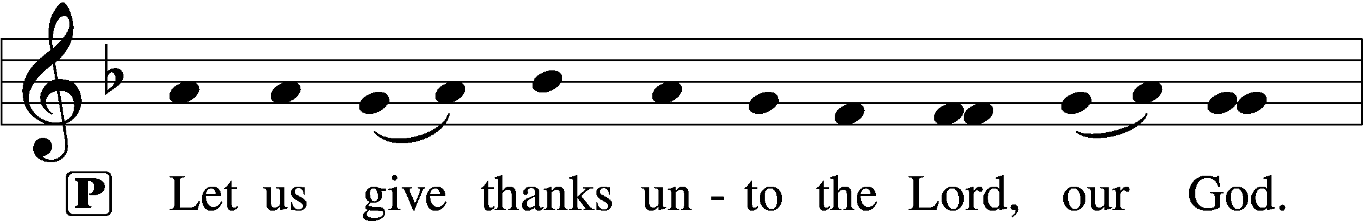
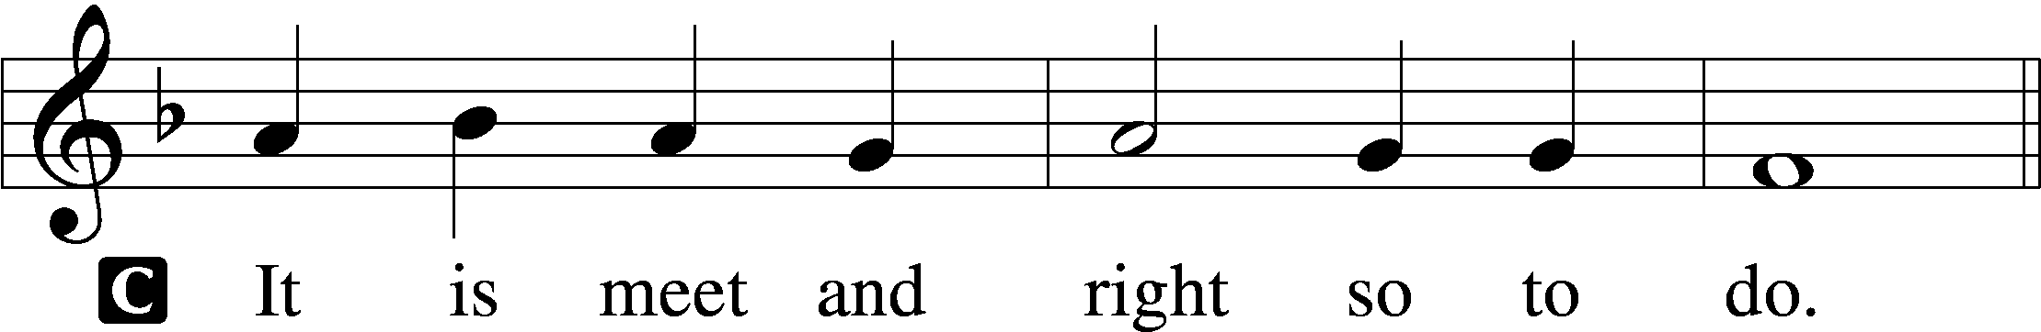

P It is truly meet, right, and salutary that we should at all times and in all places give thanks to You, holy Lord, almighty Father, everlasting God, through Jesus Christ, our Lord, whose way John the Baptist prepared, proclaiming Him the promised Messiah, the very Lamb of God who takes away the sin of the world, and calling sinners to repentance that they might escape from the wrath to be revealed when He comes again in glory. Therefore with angels and archangels and with all the company of heaven we laud and magnify Your glorious name, evermore praising You and saying:

Sanctus LSB 195
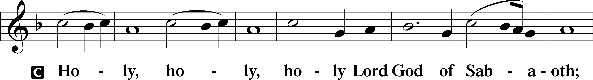
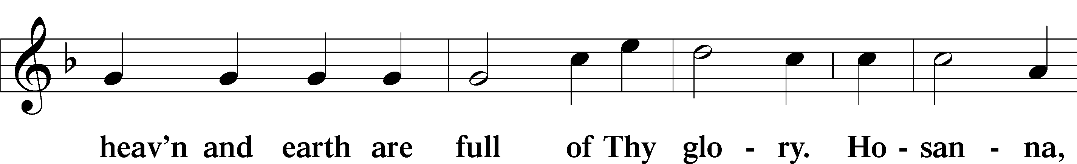
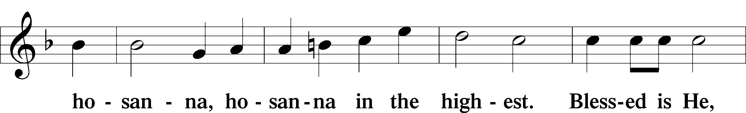
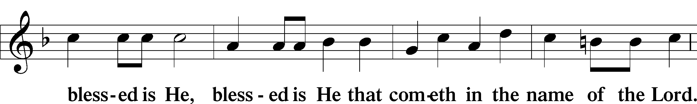
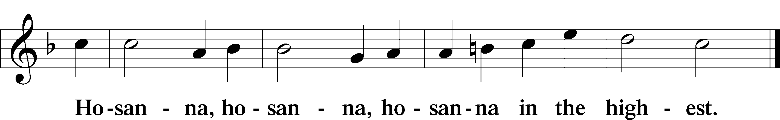

Lord’s Prayer LSB 196
C Our Father who art in heaven,
hallowed be Thy name,
Thy kingdom come,
Thy will be done on earth as it is in heaven;
give us this day our daily bread;
and forgive us our trespasses as we forgive those who trespass against us;
and lead us not into temptation,
but deliver us from evil.
For Thine is the kingdom and the power and the glory forever and ever. Amen.

The Words of Our Lord LSB 197

Pax Domini LSB 197
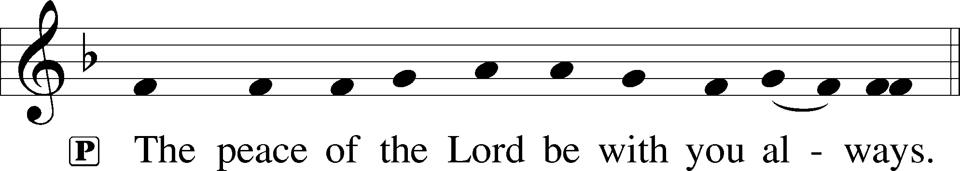

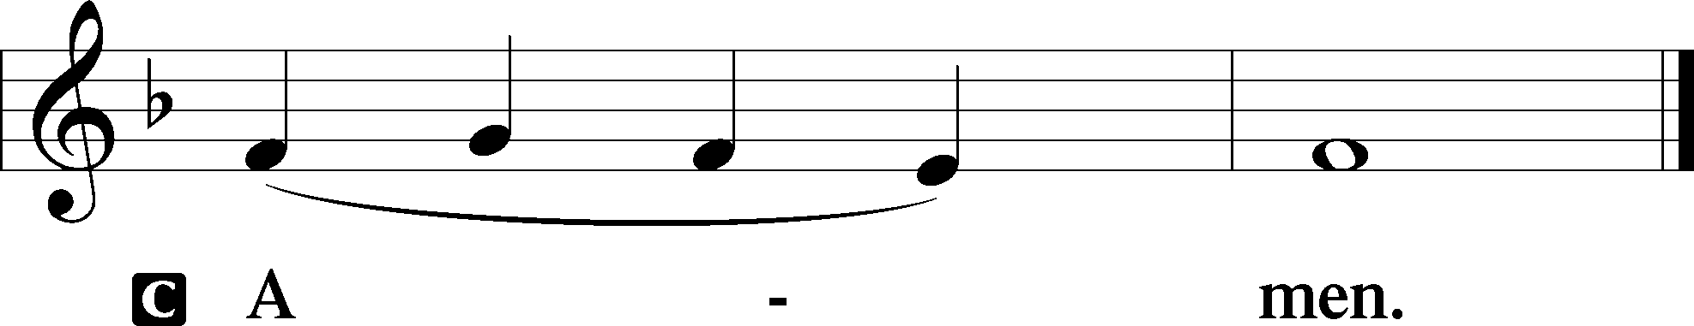

Agnus Dei LSB 198
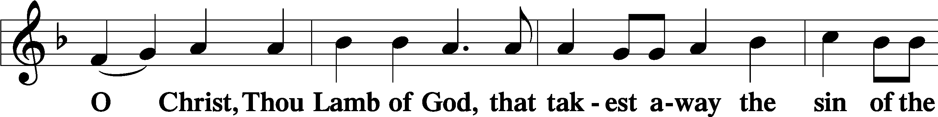
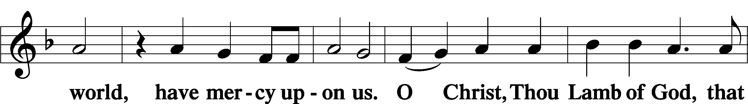
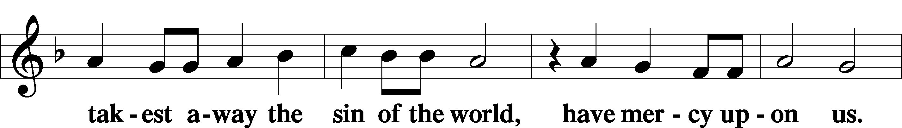
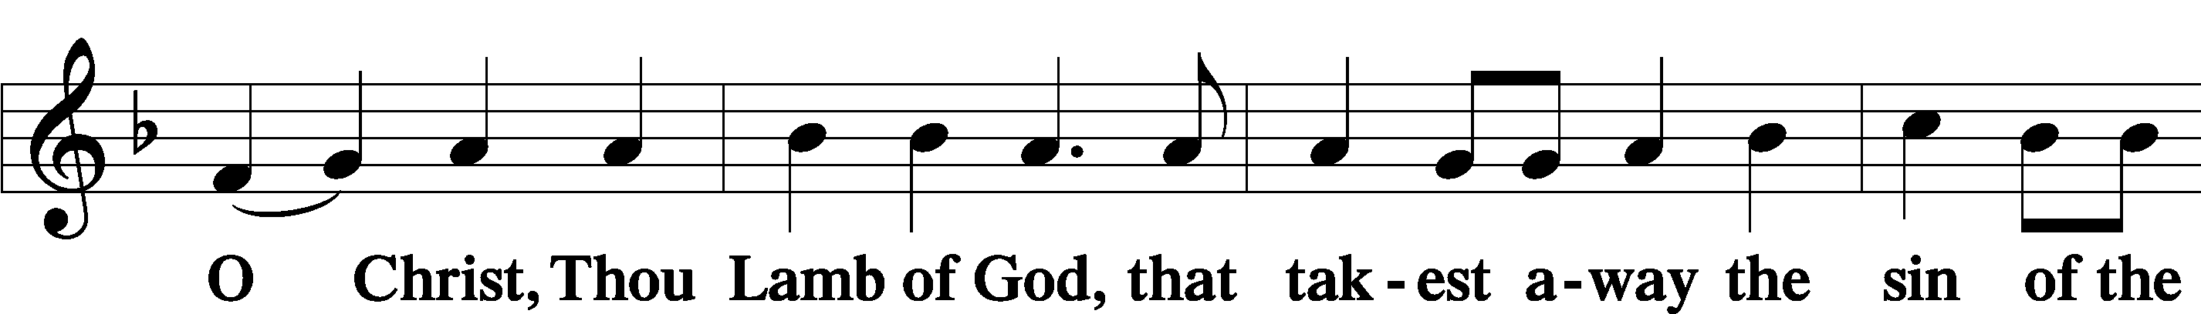

Sit

Distribution

The Sacrament of Holy Communion is God's gift to the Church. Through this gift we are fed with the very Body and Blood of Jesus Christ. When we gather together at God's table, we are also expressing our common faith and mutual commitment to the doctrine of The Lutheran Church - Missouri Synod. (Attendance at the Lord's Supper is always a confession of that which we believe.) Because of the significance of the Sacrament and because the scriptures counsel us against its misuse (1 Corinthians 11:17-32), those who have not communed previously at St. Paul's are asked to speak with the pastor or an elder before communing

Distribution Hymn: 338 Come, Thou Long-Expected Jesus
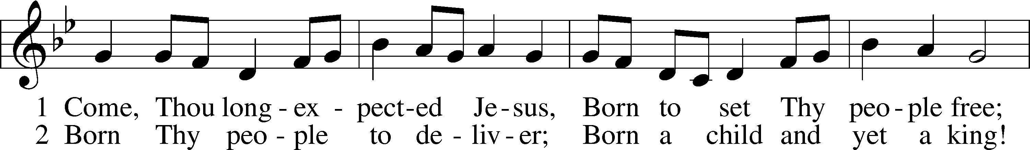
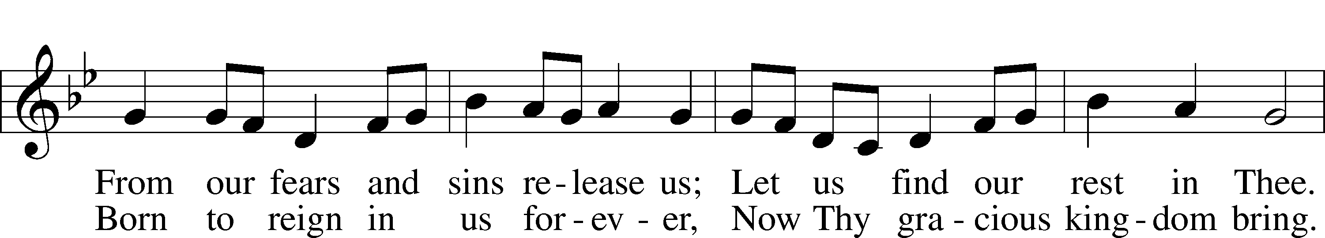
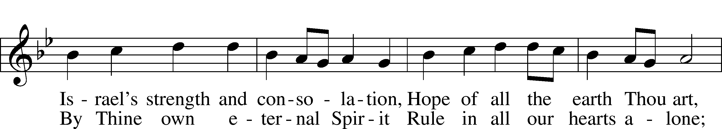
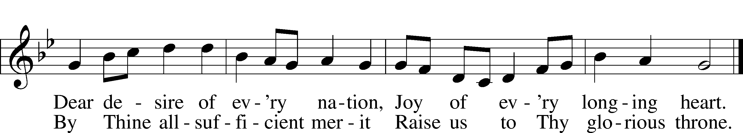

Distribution Hymn: 355 O Savior, Rend the Heavens Wide
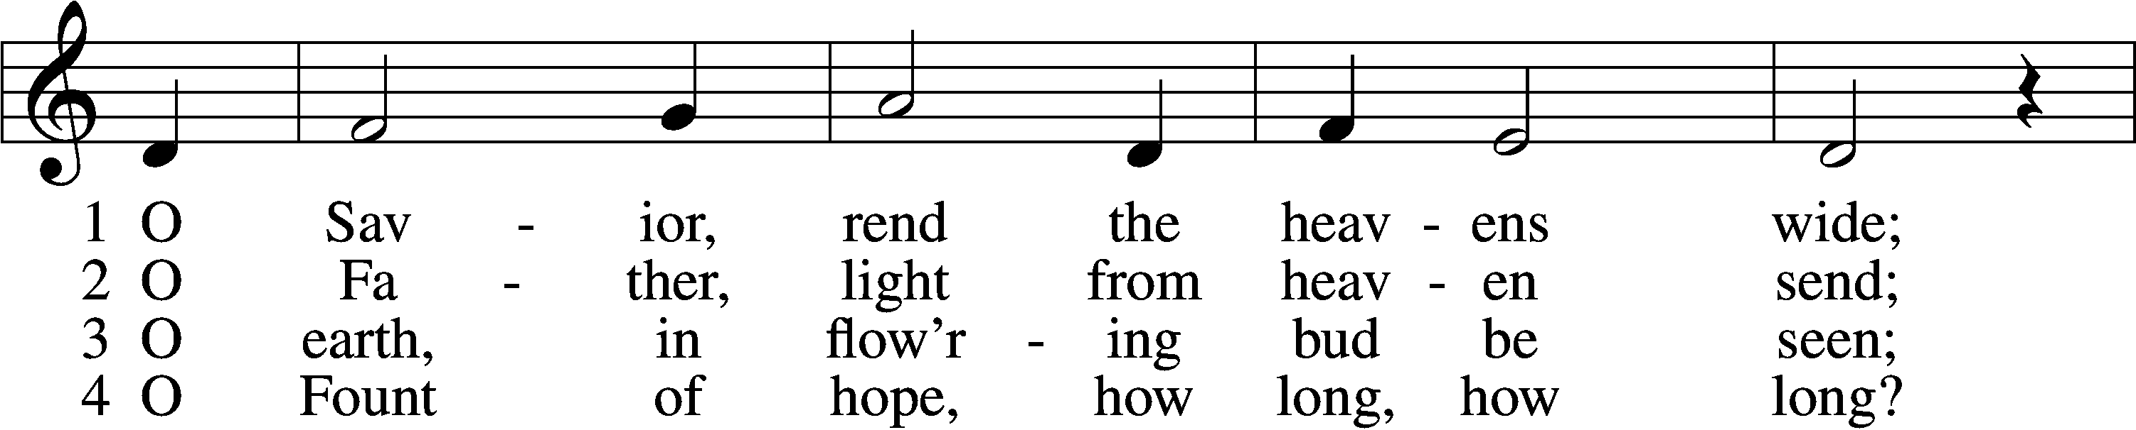
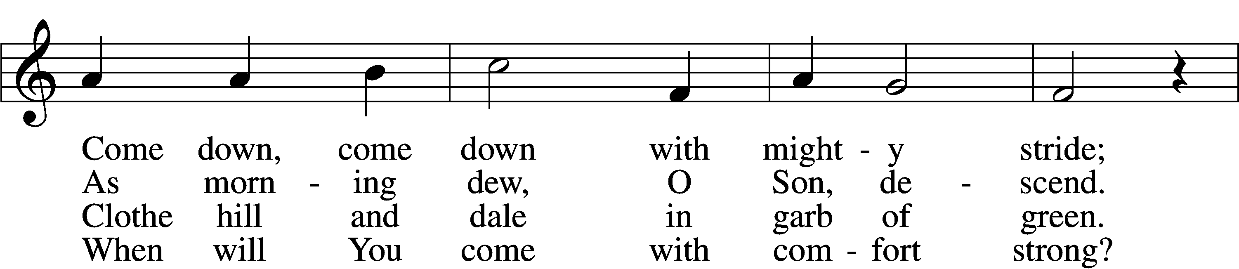
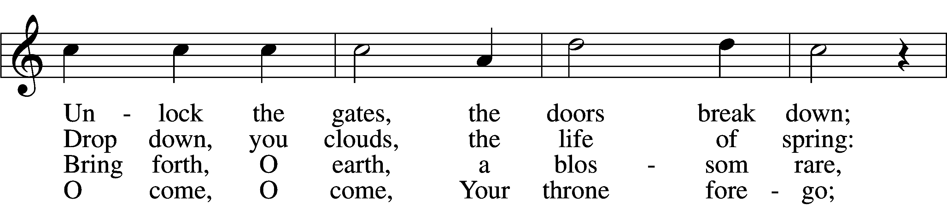
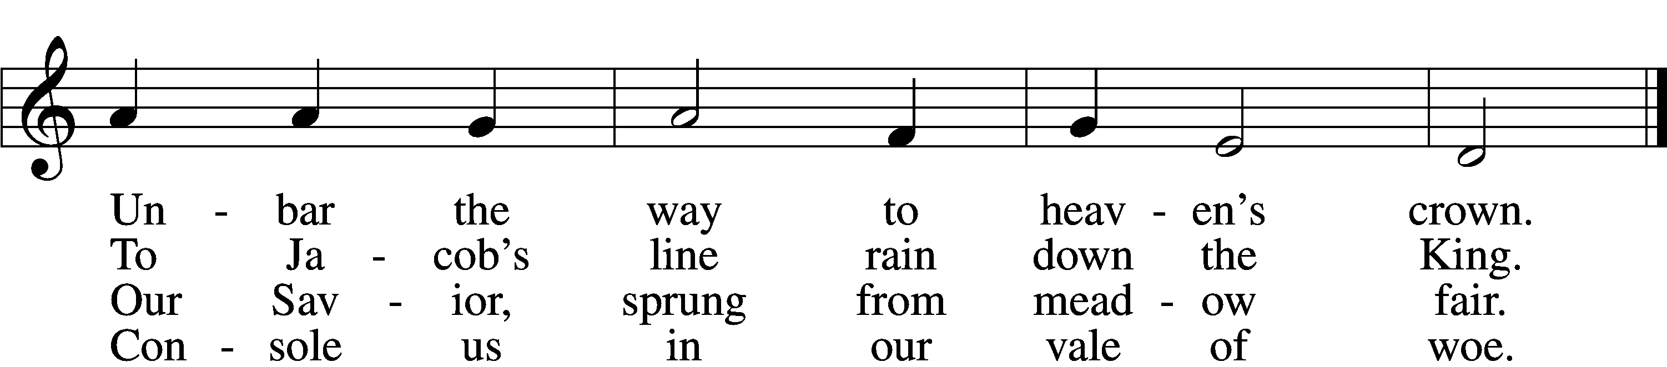

5 O Morning Star, O radiant Sun,
When will our hearts behold Your dawn?
O Sun, arise; without Your light
We grope in gloom and dark of night.

Continued next page>

6 Sin’s dreadful doom upon us lies;
Grim death looms fierce before our eyes.
O come, lead us with mighty hand
From exile to our promised land.

7 There shall we all our praises bring
And sing to You, our Savior King;
There shall we laud You and adore
Forever and forevermore.
Stand

Nunc Dimittis LSB 199
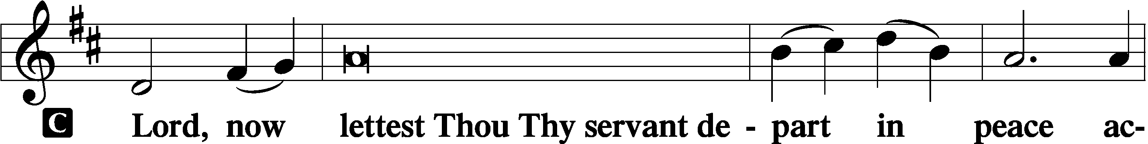

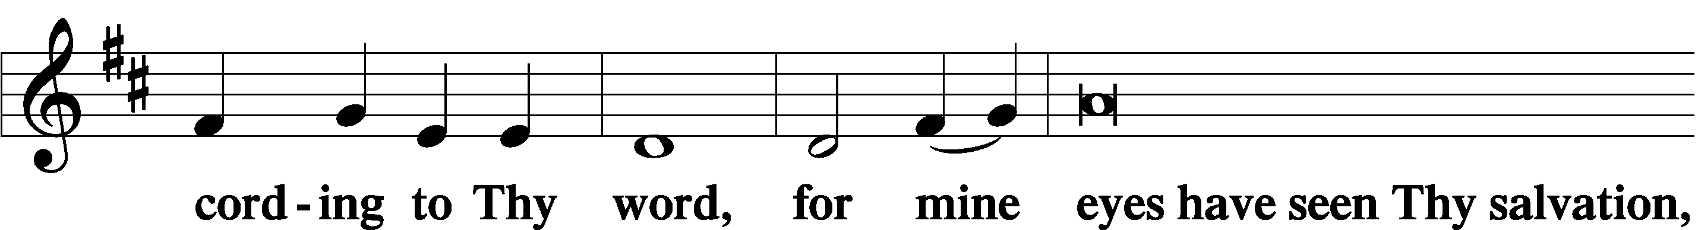

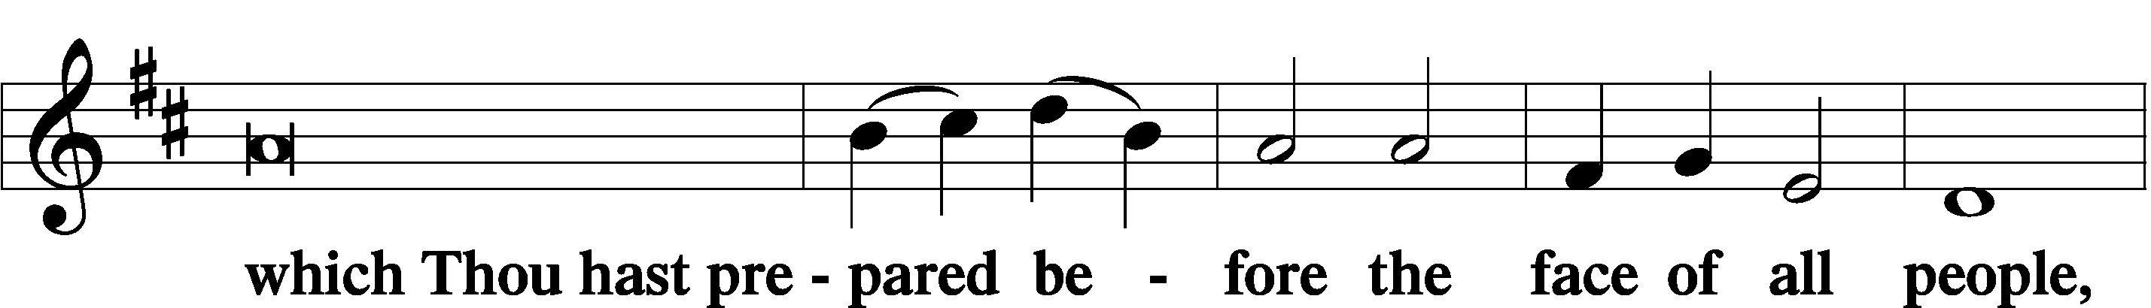

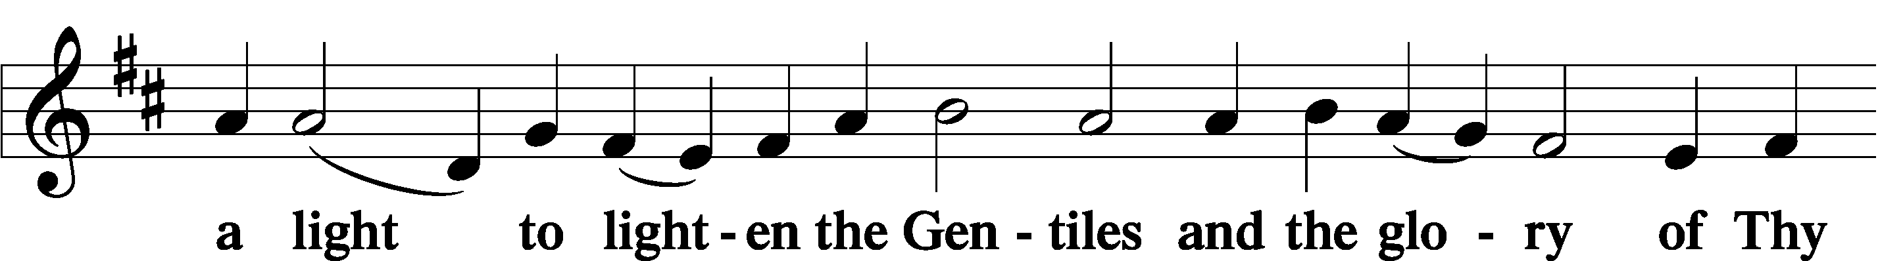

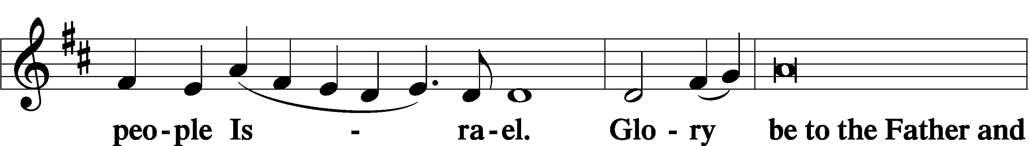

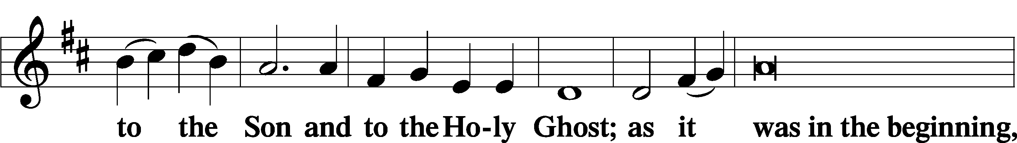

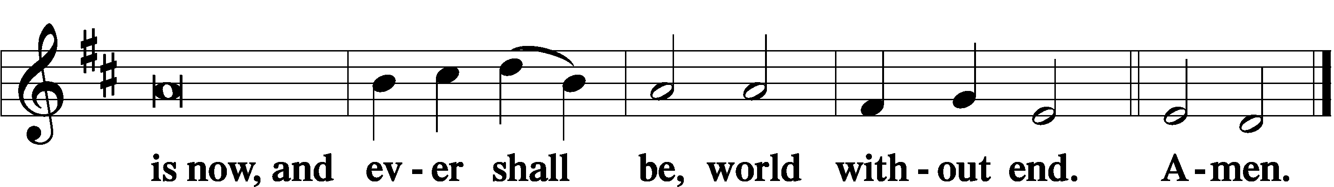

Thanksgiving LSB 200
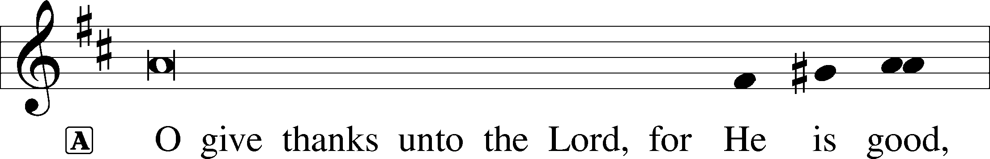

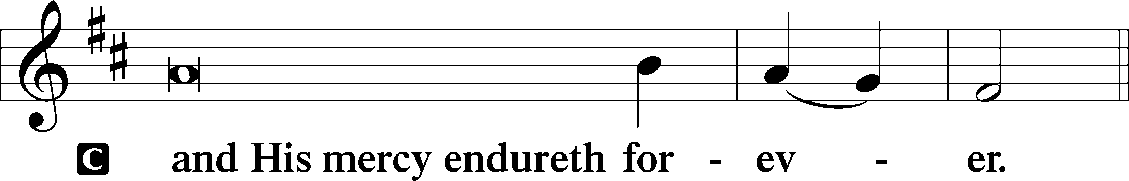

A Let us pray.
We give thanks to You, almighty God, that You have refreshed us through this salutary gift, and we implore You that of Your mercy You would strengthen us through the same in faith toward You and in fervent love toward one another; through Jesus Christ, Your Son, our Lord, who lives and reigns with You and the Holy Spirit, one God, now and forever.

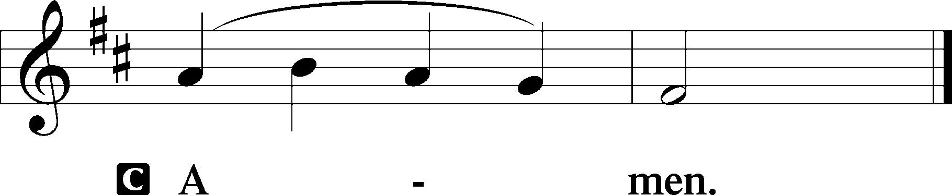

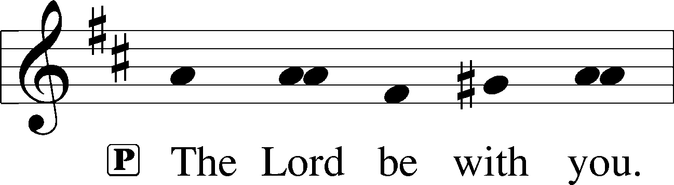

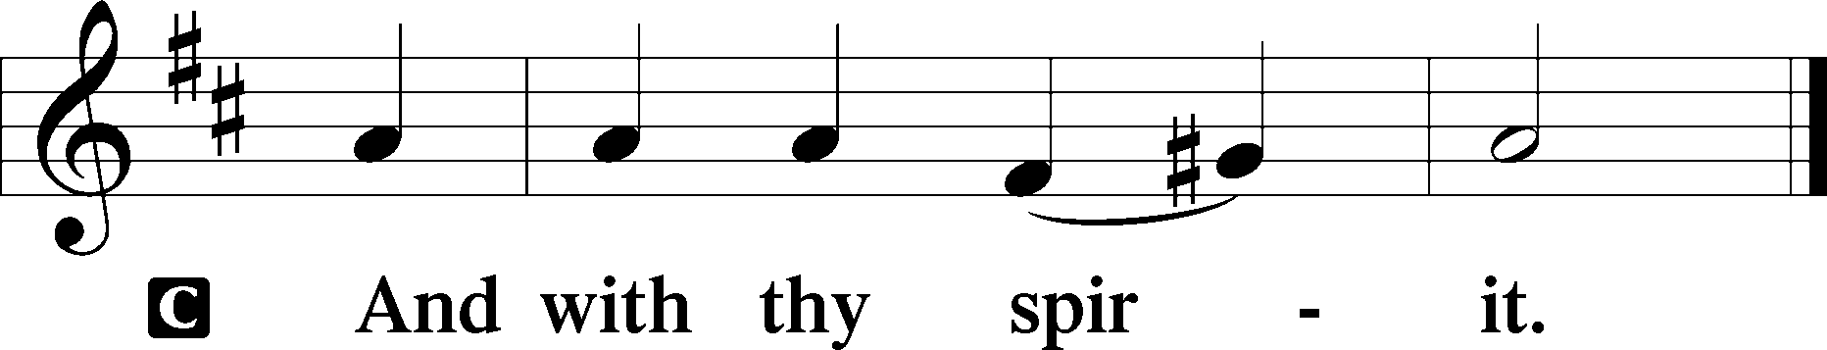

Benedicamus LSB 202
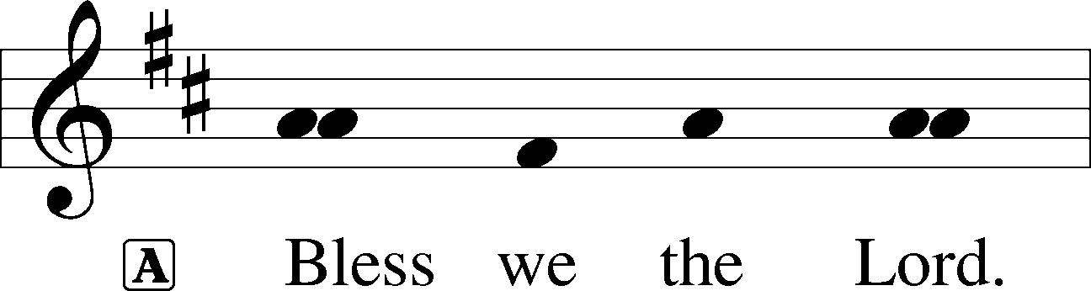

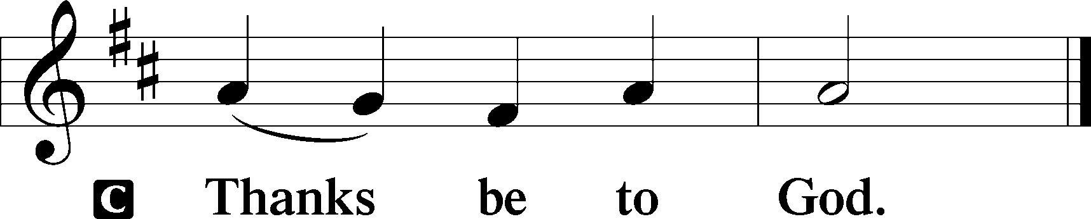

Benediction LSB 202
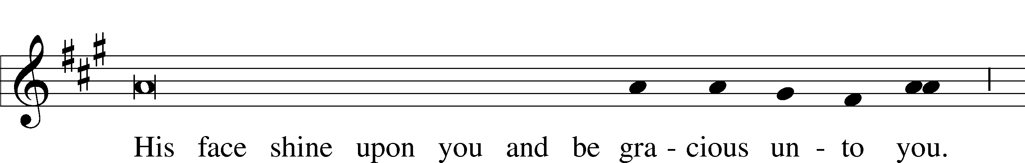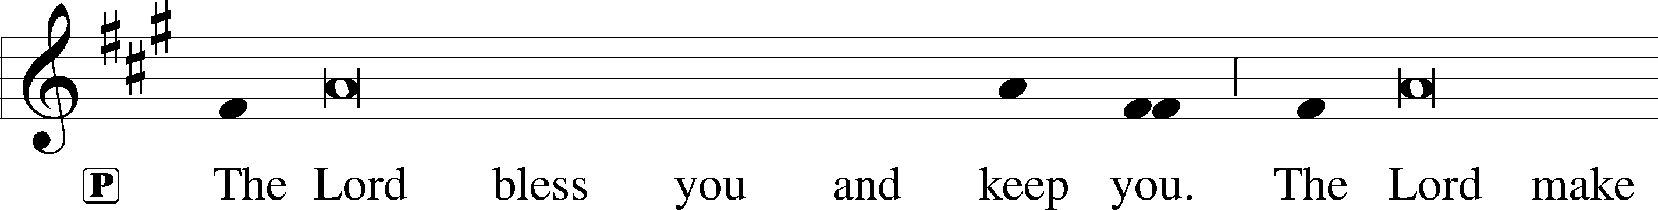

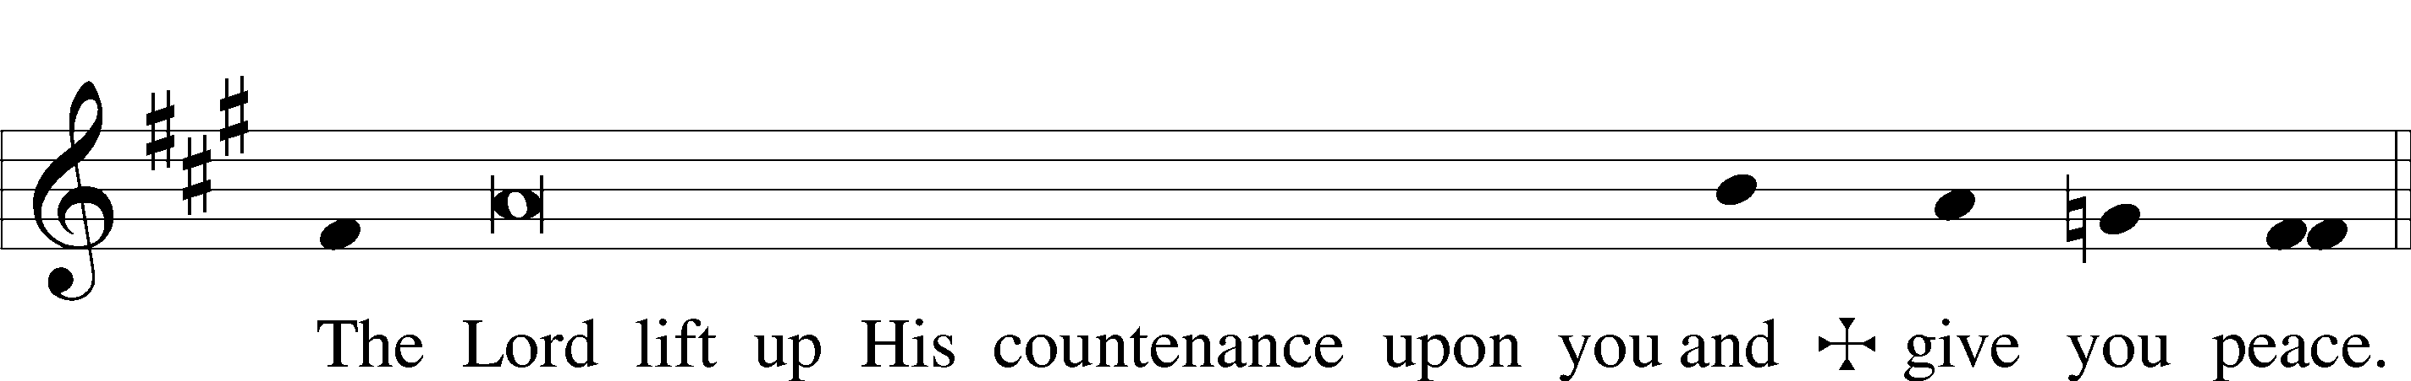

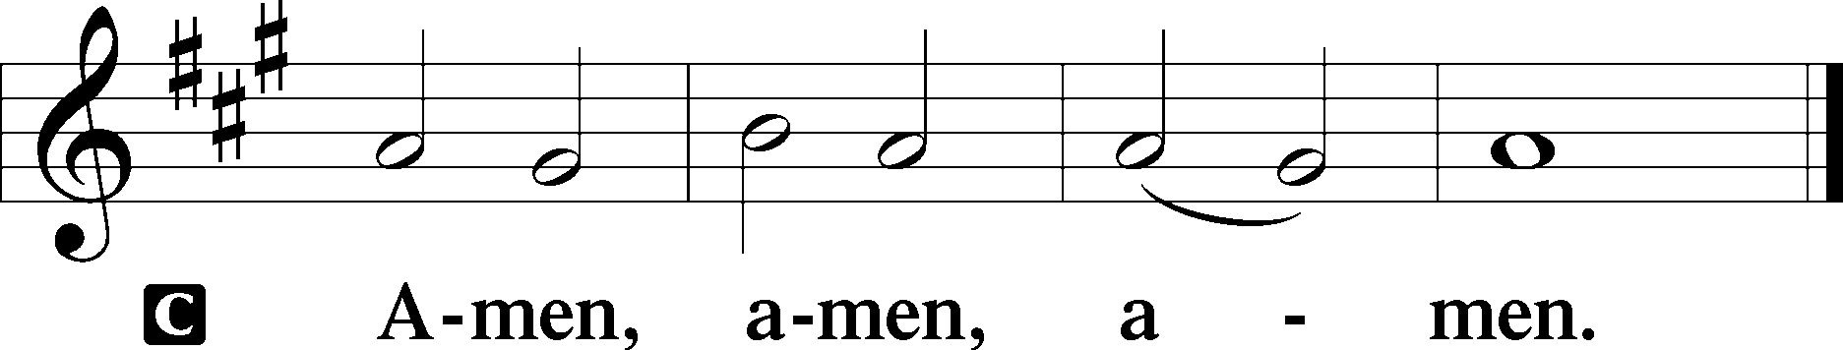

Sit

Hymn: 341 Lift Up Your Heads, Ye Mighty Gates
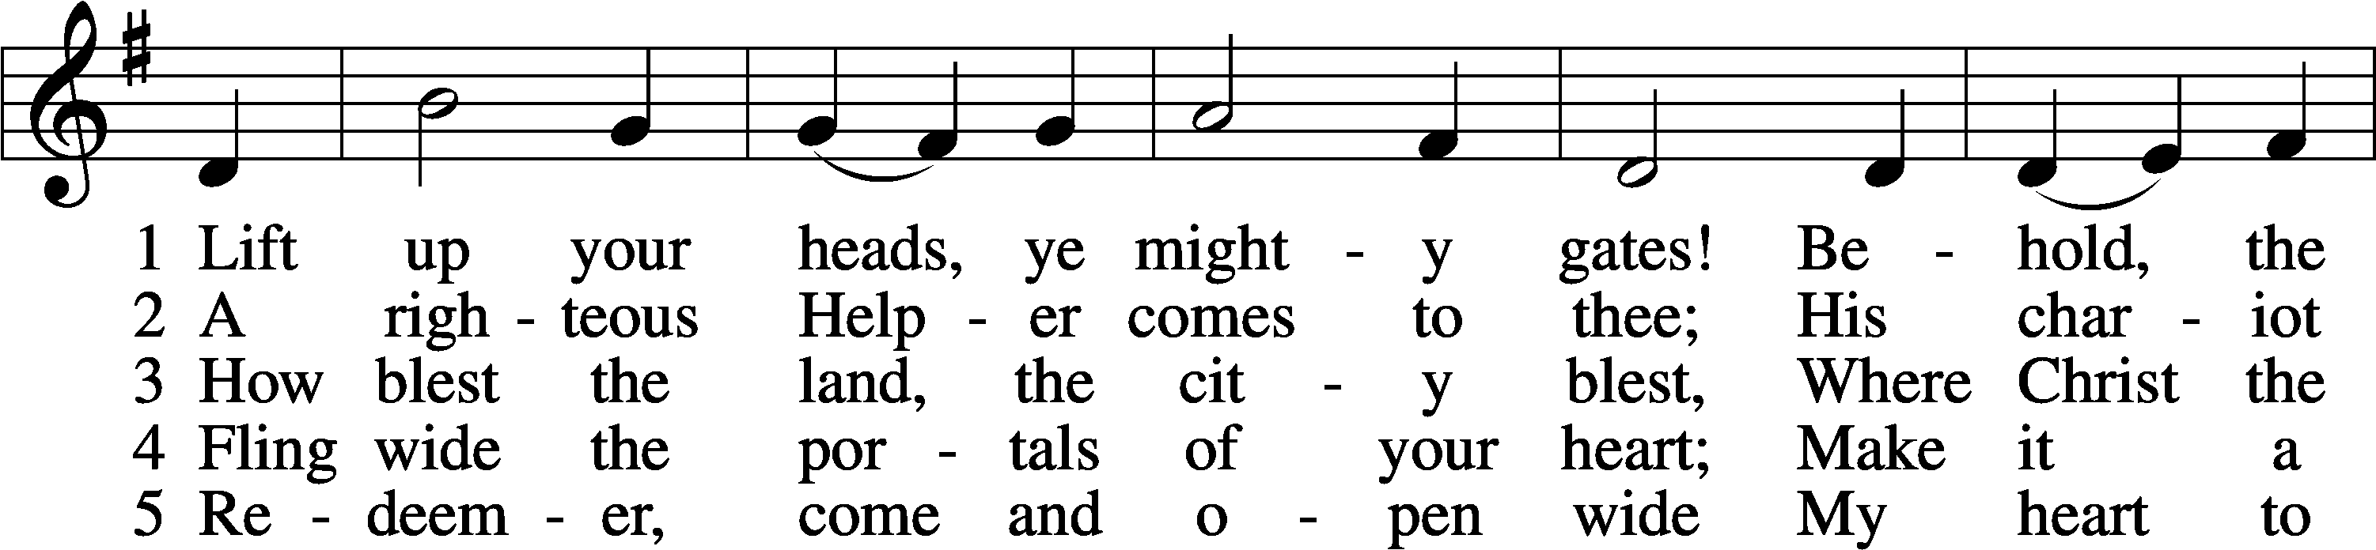
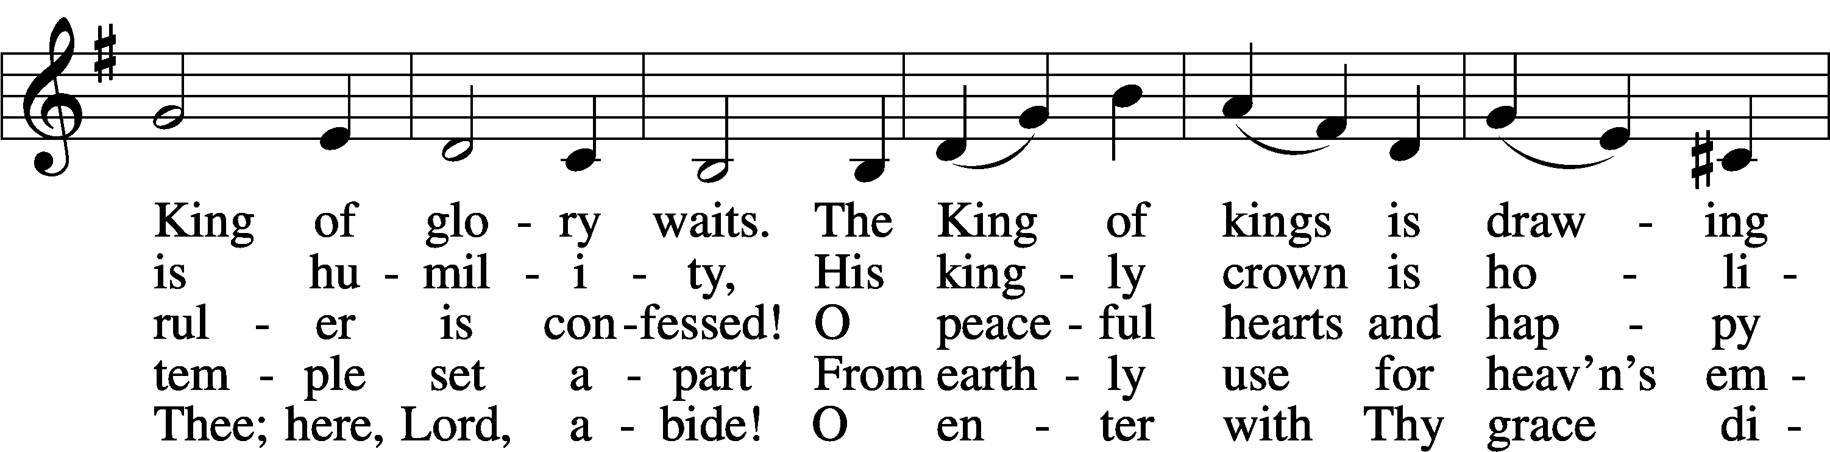
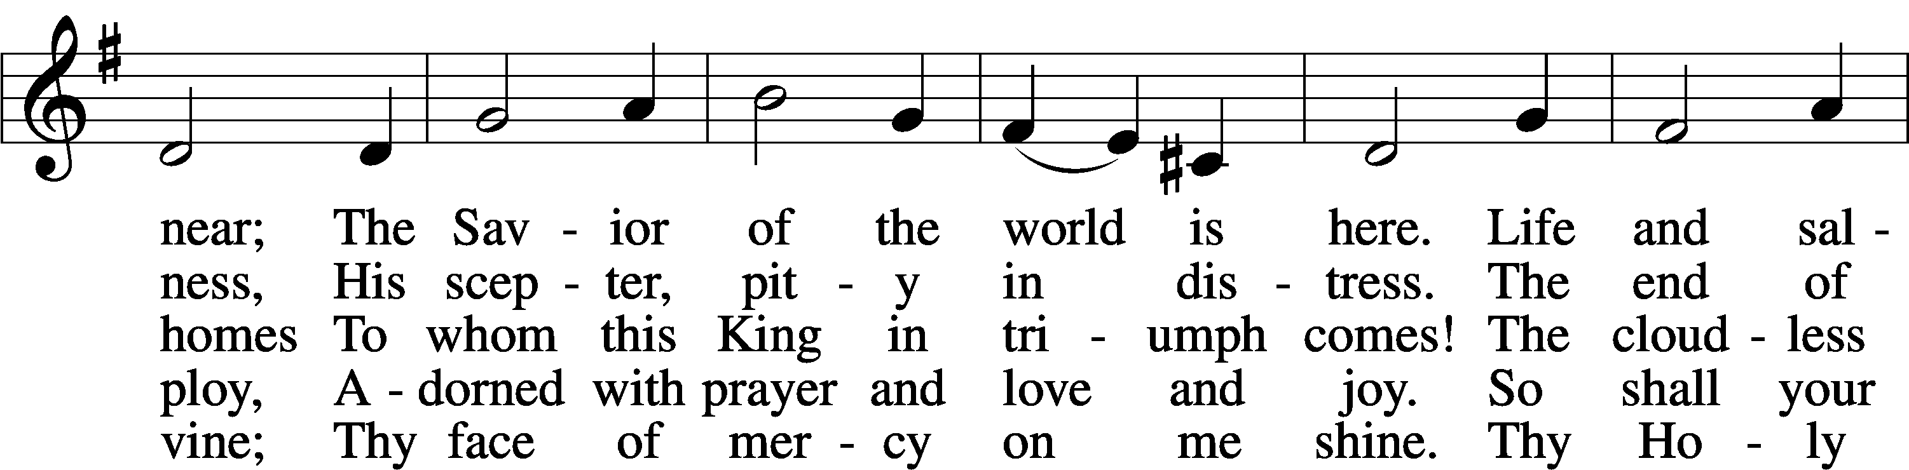
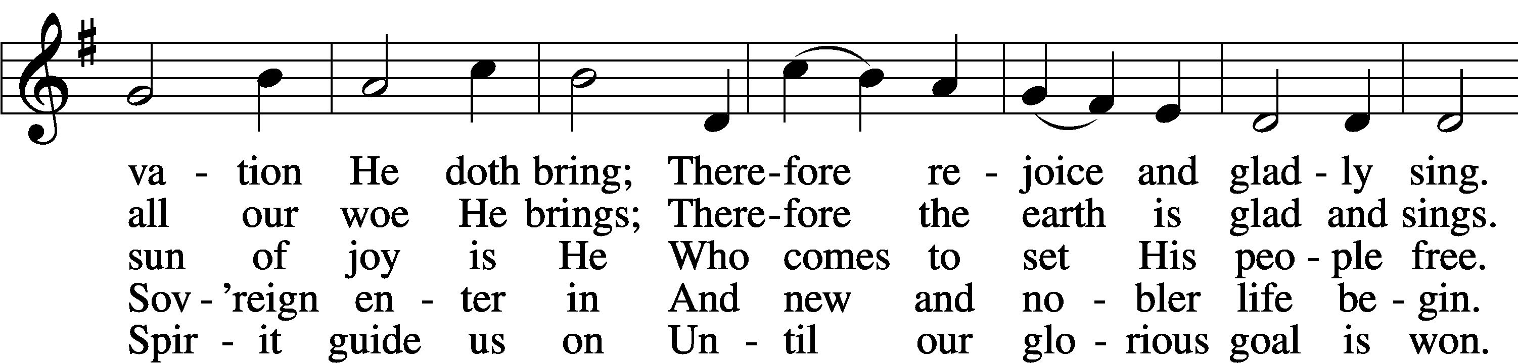
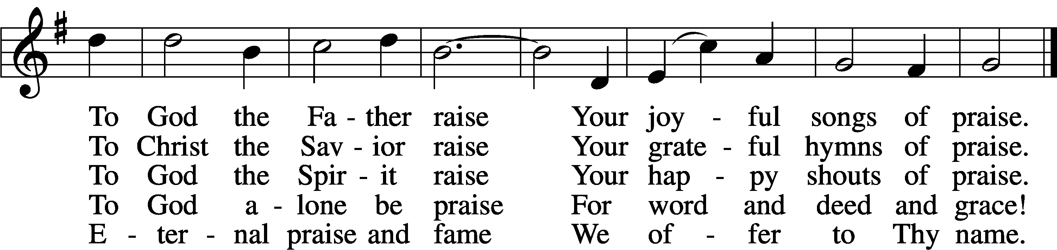

Dismissal for Sunday School

Dismissal for Youth Bible Study

P Go in Peace, serve the Lord

C Thanks be to God.

Postlude
Church Office: 989-687-2824
E-Mail: stpaullutheran@tds.net | www.stpaulsanford.org

WELCOME:
We join in welcoming our visitor’s this morning. If you would please be sure to sign the guest book (Elders can direct you to the location), Thank you!
 | THIS WEEK AT ST PAUL
 | SUNDAY: First Sunday in Advent-Worship Service with Communion 9:30am/10:30am/ Fellowship/Sunday School/ 11am Bible Study
 | MONDAY:
 | TUESDAY: Confirmation Class 5pm
 | WEDNESDAY: Advent Dinner 6pm/Advent Service 7pm/Choir-after service
 | THURSDAY: Pastor Hoogerhyde Bible Study 2:30pm 105 E. Youngs Ct. Midland/Elder’s Meeting 6pm
 | - FRIDAY: Stephen Ministry Training Class 10am/Sanford Shines Parade Set up 5pm-Parade Starts @ 6pm
 | - SATURDAY: Men’s Breakfast 8am/Band Rehearsal 4pm/Youth Movie Night 6pm
 | SUNDAY : Second Sunday in Advent-Worship Service 9:30am/10:30am/ Fellowship/Sunday School/ 11am Bible Study
OUR GIFTS TO THE LORD 11/22
OFFERINGS  Env / Plate |  | mom | Memorials | TOTAL | ATTENDANCE
$254/185 |  | - | - | $439 | 50

OUR GIFTS TO THE LORD 11/26
OFFERINGS  Env / Plate | mom | Memorials | TOTAL | ATTENDANCE
$2707/256 | - | - | $2963 | 80

Joy to the World, The Lord has come!
The Reith’s invite the ladies of St. Paul to celebrate an afternoon of Christmas fellowship Thursday, December 7th @ 1pm. 2152 Lynn Rd. Sanford.
Please RSVP to Ann Reith, or use the sign up sheet on the bulletin board

The most delicious Peanut Brittle you will find on sale now-$10/bag. Please see a Ladies Aid member for purchase. You will be glad you did :)

Ladies Aid ~ End of year meeting will be December 27th@ 10am

2023 Sharing Tree : A sincere thanks to all who helped and provided gifts for the sharing tree. Your gifts and prayers mean so much to so many. We were able to fill 12 requests from the cards. God bless you and yours as you celebrate HIS birthday this CHRISTMAS and in 2024. Thank you from Erin Teachworth.

Holiday Gift Baskets - Please consider donating this Christmas time. We will have Holiday Gift Baskets set up in the fellowship hall to distribute to a few families as Christmas approaches. Please, let us know if you are aware of someone in need this Holiday Season.

Mission of the Month: In December is the Life Clinic of Midland County. The LifeClinic, provides information so individuals can make the most informed, empowered decision possible for their physical, mental, and emotional health and that of their unborn child. Poster for the narthex is coming soon

LWML 2024 Michigan District Convention-June 28-30, 2024 at Amway, Grand Rapids

LWML Prayer Day/Spring Rally 2024 at St Paul, Sanford. Date to be determined. For more LWML information, Please contact Diana Kausch.

Youth Movie Night-Saturday,December 9th @ 6pm featuring the “Polar Express”. Pizza/poporn/smores and movie discussion.

For more information about youth group, Sunday School, youth bible study and events, please use the QR code to get to the form.

Prayer Request: If you or someone you know are in need of prayers please call or email Edna Rottiers at 989-687-9687 / hughrottiers@gmail.com . Those with additional prayer request please complete a prayer slip and give to one of our Elders before the service or to one of the Ushers during the offering. Your prayers are important and our Lord does promise to answer

December Altar Guild representative is Carolyn Sutton 989.631.3953

Choir Practice-This week Wednesday after midweek service.

Budget meeting is in December. If you would like to be add anything to the budget, please speak with Curt, Julie or Jan for consideration.

January meeting will include voting for board members. Please let board know if you are interested.

To our families with small children: Relax! You and your children are welcome to our worship service! Being in worship with you to observe and participate in the service will help them to learn how to behave in church – and they will learn that best by watching you worship on a regular basis! Sit anywhere in the sanctuary that you wish. The last two rows of pews are set aside for families with small children, but you don’t have to sit there. In fact, sitting close to the front so your children can see what’s happening may help them to feel more involved in the service. If they need something to keep their hands occupied, please ask one of the ushers for a copy of the children’s bulletins for them to color. If for any reason you need to take your children out of the sanctuary so they can calm down, feel free to bring them into the bathroom at the back of the church. In addition, at the bottom of the stairs we have a cry room to the right, as well as the fellowship hall to the left. With the speakers in the basement, you will be able to hear the service while your child calms down. If your children don’t want to sit still or be quiet through the whole service, there is absolutely nothing wrong with them: they are young and learning. The sound of children in worship is the sound of the Church’s future.

Blacktop Project-We are accepting donations to the Blacktop project as we work toward the upgrade to the parking lot in the future.

Pastoral Care: Please contact the Pastor @ cell 973-303-8252, office 989-687-2209, or email stpaulrev@tds.net. The Church Office (989-687-2824) / cell (989 859-9300) email stpaullutheran@tds.net, or Deacon Don Barnard (989-751-7726) email: stpauldeacon@tds.net or esocidnator01@gmail.com if you or anyone you know are in need of a visit from the Pastor or Deacon whether it’s an illness, hospitalization, nursing home or shut-in. It is important to us that we receive these communications to plan a call or visitation. May God’s blessings be upon you today and every day!

Please remember to lock the Church doors and turn out the Lights

#Up Coming Events#

Midweek Advent Services begin December 6th at 7pm. Advent dinner before service at 6pm-free will offering. First dinner is sponsored by Ladies Aid.

Youth Movie Night-Saturday,December 9th @ 6pm featuring the “Polar Express”. Pizza/poporn/smores and movie discussion.

Saturday, December 16th Cookie Decorating

Children’s Christmas Concert-December 17th @ 4pm

January 19th @ 6pm Wild Game Dinner with Guest Doug Roberts of ConQuest Scents

January 28th, 1pm Youth Group outing to the Live Oak Café, Midland where we will be brainstorming youth activities.

3 Lent Crosses – First showing of the 3 crosses made by Mike Schweigert, Randy Engblade, and Don Retzloff will be Feb 11th

SERVING | This Week 12/03 | Next Week 12/10
Flowers: | Open | Open
Music: | Heidi Stecker | Heidi Stecker
Proclaimer: | Pastor Christopher P. Vossler | Pastor Christopher P. Vossler
Fellowship Host | Myrna & Christy & Patty | Open
Ushers | Jack Moeller & Duane Grubaugh | Carolyn Sutton & Edna Rottiers
Acolytes | Jeffrey & Sam | Lucas & Garrett
Greeters | Laura Juengel & Marilyn Bowen | Laura Juengel & Marilyn Bowen & Jace Eshleman

ST PAUL LUTHERAN CHURCH
2023 HOLIDAY SCHEDULE
2045 Lynn Road * Sanford, Michigan * 989.687.2824
Website: www.stpaulsanford.org

CELEBRATE ADVENT & CHRISTMAS
December 3rd – December 25th

DECEMBER
Sunday the 3rd 9:30am Advent I Worship/Communion
Wednesday the 6th 6pm Dinner
7pm Advent I Communion
Sunday the 10th 9:30am Advent II Worship
Wednesday the 13th 6pm Dinner
7pm Advent II Worship
Sunday the 17th 9:30am Advent III Worship/Communion
4pm Children’s Christmas Concert
Wednesday the 20th 6pm Dinner
7pm Advent III Worship

CHRISTMAS WEEK
Sunday the 24th9:30am Advent IV Worship
Sunday the 24th 6:30pm Christmas Eve- Candlelight Service

Christmas the 25th
9:30am Worship

NEW YEAR’S EVE
9:30am Worship/Commemoration of the Faithful Departed
Sanford Food Pantry: The current needs for the Food Pantry are Boxed Potatoes-Scalloped, AuGratin, Mashed. There are refillable canvas bags from the Midland County Emergency Food Pantry available on the food pantry table in the fellowship hall. The bags have a suggested list of items and instructions. You may take these bags home and place the purchased items in the bag and return it to the church. The bags will be delivered to the Sanford Food Pantry the last week of the month. The empty bags will be returned to the church to be used again. Thank you for all of the items and monetary donations. Please remember that the food pantry does not accept expired or dietary food.

Interested in joining the Youth Ministry Board,. Next meeting is Thursday, January 25th @ 6pm. The board will focus on the planning of education and activities designed for our congregation’s youth. Please let Gerianne or Pastor know if interested.

St. Lorenz Church in Frankenmuth invites you to the 73rd annual Christmas at St. Lorenz concert on Saturday, December 9th at 6:30pm. Please join us in this festive celebration of Christ's birth with the theme, NOVA (New Light in Christ). The program will feature choirs, wind ensemble, handbells, organ and congregational song, with exciting renditions of familiar carols. There is no admission charge. A freewill offering will be welcome.

-Thank you,
From the St. Lorenz Church Music Ministry.

December 8 marks the anniversary of the declaration of war that began the involvement of the United States into WWII. Since then, brave men and women have defended America and the Constitution. The Lutheran Center for Religious Liberty also works to defend the country and the Constitution. Presented by The Lutheran Center for Religious Liberty (LCRL). See www.LCRLFreedom.org for more information.

Read the Bible in a Year!

“All Scripture is breathed out by God and profitable for teaching, for reproof, for correction, and for training in righteousness, that the man of God may be complete, equipped for every good work.” (2 Timothy 3:16-17)

For Christians – and especially for Lutherans – nothing is more important that God’s Word. God speaks to us through His Word, and we do well to listen to what He has to say to us. That is why regular devotions and prayer and Scripture reading are so important for our spiritual life.

It’s always a good time to start a plan to read the Bible! And in fact, you can read through the entire Bible in a year, with only 15-20 minutes per day. Are you worried that the Bible might be too much for you to read in a single year? There are resources that can help. One option that is available is on your smartphone: Download the YouVersion Bible App and look up the “Reformation Reading Plan,” which was developed by the Michigan District to celebrate the 500th Anniversary of the Reformation in 2017.

If you don’t have a smartphone, you can follow this reading plan in the bulletin every week, along with suggested readings from Luther’s Small Catechism. Note that whatever day you start the reading plan in the app will be “Day 1,” so you may find yourself on a different day than what is in the bulletin.

Daily Readings:
Days 36-42 | Reading | Catechism
Monday | John 19: 1-27, Isaiah 22,23,24,25 | Confession
Tuesday | John 19: 28-42, Isaiah 26,27,28 | A short form of confession
Wednesday | John 20,21, Isaiah 29,30,31,32 | The office of the Keys
Thursday | Romans 1, Isaiah 33,34,35,36 | The Sacrament of the Altar
Friday | Romans 2, Isaiah 37,38,39 | The nature of the Sacrament of the Altar
Saturday | Proverbs 3: 13-26, Psalms 21,22,23 | The benefit of the Sacrament of the Altar
Sunday | Isaiah 40: 1-11, Psalm 85, 2 Peter 3: 8-14, Mark 1: 1-8 | The Power of the Sacrament of the Altar

Daily Devotion Resources:
Daily Prayers for Morning, Noon, Evening, Close of Day
(LSB 294-298)/Treasury of Daily Prayer/Portals of Prayer
Prayer Requests:

- Youth in the Church, especially our Confirmands
- Our Shut-ins
- Peanut Brittle Sales
- Pastors of our congregation and Synod, and for increase in the numbers of Seminary students for future Pastors

